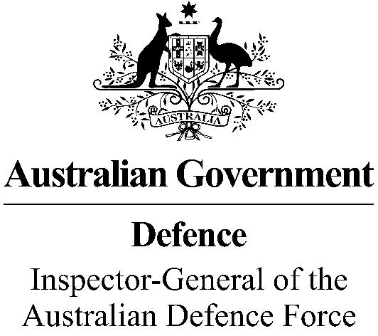

***Sharing IGADF information with the Royal Commission***

I write this message to make clear what you can and can’t discuss with the Royal Commission into Defence and Veteran Suicide regarding your experience in an Inspector-General of the Australian Defence Force (**IGADF**) matter.

It’s important to note this message does not affect any Court or Tribunal order restricting disclosure of IGADF information. You must comply with any such order.

IGADF examines sensitive matters. IGADF staff will sometimes issue directions restricting the disclosure of information.

I authorise you to disclose any IGADF information to the Royal Commission on the following conditions:

* You must inform the Royal Commission of any non-disclosure direction so that it can appropriately deal with the information.
* You must not disclose information from the IGADF Afghanistan Inquiry.

Finally, the Royal Commission has co-signed an agreement with the Australian Defence Force (ADF) and Departments of Defence and Veterans’ Affairs to provide [stronger legal protections](https://defenceveteransuicide.royalcommission.gov.au/share-your-story/protections) for serving and ex-serving ADF members who voluntarily share information relating to its [terms of reference](https://defenceveteransuicide.royalcommission.gov.au/publications/plain-english-terms-reference).

**James Gaynor CSC**

**Inspector-General of the Australian Defence Force**

**April 2023**